**Mohammed Saad Alsekaiaan**

* First of all, I retrieved the data into a CSV files from the database using this SQL lines:
* Fist line was about the city_list table, to fine my city:

**Select * From city_table Where city= ‘Riyadh’;**

* After finding my city I had to retrieve its data from the city_data table using:

**Select * From city_data Where city= ‘Riyadh’;**

* And my last line was about retrieving the global teperture from the global_data table using:

**Select * From global_data:**

* After that I started analyzing the data by calculating the moving averages of both my city and the global temperature. I used Excel and its function =Average (the first average by the cell number: the last average by the cell number).
* The next step I inserted a line chart to represent the moving averages of both data in a visible way.
* My key consideration was to find a way to visualise the moving average in an easy way for the reader so they can find what they’re looking for. And also a way that will help me to fine the required observations.
* **A screenshot of the excel sheet to show the 10 years moving average calculation:**

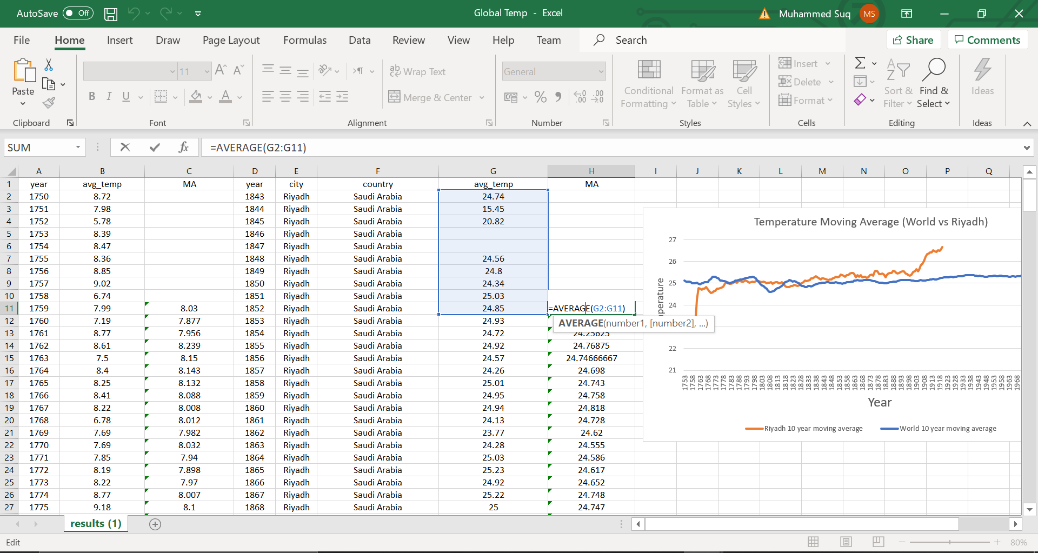

* **A screenshot of the chart, I made a change by showing both studies on one chart, it’s a really good idea.**
* **Observations**:
* As we see that my city’s moving average is very high comparing to the glob, Riyadh’s moving average temperature lies between 24 and 27, but the global moving average lies between 7 and 10 which is very low comparing to Riyadh.
* Riyadh’s moving average is going up almost all the years, but the global moving average is almost consistent.
* At the begging of the 90s both my city and the global temperatures went higher, but as we see the globe’s temperature went only one degree higher, but Riyadh went higher for almost two degrees.
* As the study shows that the moving temperature average is going up almost one degree every 10 years for both the globe and my city, I expect the average to move higher at the end of this decade.